Activity 1 - Talking about general subjects and giving opinion.

1. Watch the video: https://www.youtube.com/watch?v=qtmf_k5q9us
(Asking for and Giving opinion - Agreeing and disagreeing in English)
2. Listening:
https://learningenglish.voanews.com/a/how-to-express-your-opinions-in-english/4755937.html
Transcription:
Suppose you are with a group of friends discussing the greatest inventions of the 20th century.
One friend says, “I think the computer was the best invention. There’s no question about it.”
Another friend says, “I disagree! Have you forgotten that airplanes exist?”
The first one responds with, “Actually, today’s airplanes could not operate without computers.”
Knowing how to express your opinion in English is valuable whether you are speaking or writing. In today’s program we will look at phrases you can use to share your point of view.
Common phrases
Many phrases are suitable in everyday speech and some types of writing, such as on blogs and personal websites. You have probably already seen or used some of these phrases:
I think…, I believe…, I feel…, In my opinion… and I would say…
For example, imagine you have your own food website. Today you’re writing or talking about the world’s best street food. You might say:
In my opinion, Bangkok has the best street food.
Add strength
But suppose you wanted to make the statement stronger. You can do it by adding an adverb or adjective. For example:
I really think…, I strongly believe…, I truly feel… or In my honest opinion…
In addition, giving reasons for your opinion adds strength to the claim. Let’s hear the street food statement again:
In my honest opinion, Bangkok has the best street food. I have never seen more choices of what to eat – and everything I’ve tried has been delicious!
Formal phrases
Next, let’s look at a few phrases that are more common in formal situations. You might, for example, hear one of these at a business meeting or a conference, or in a formal paper:
From my point of view…, From my perspective…, In my view… or It seems to me that…
Here’s an example:
In my view, cruise ships should be banned. They produce massive amounts of waste and use the dirtiest fuel in the world.
Though phrases like “In my view…” are usually more formal than ones like “I think,” there is no rule for where or when you can use them. It’s often a matter of personal choice.
Asking for opinions
So, imagine you’ve expressed yourself. But what about the opinion of others? Often, when we express an opinion or suggestion, it’s a good idea to ask other people for theirs. Phrases like this help show our desire to hear from others:
What do you think of…?
What are your thoughts on…?
How do you feel about…? and
What’s your opinion on…?
You can use these questions in many kinds of situations. You might ask, for instance:
What’s your opinion on Futbol Club Barcelona?
How do you feel about the new art director?
What are your thoughts on tonight’s activities?
Agreeing & disagreeing
Finally, let’s talk about agreeing and disagreeing.
Agreeing is the easy part. To show agreement, you can use short, clear statements. Let’s suppose a friend says, “I think summer is way more fun than winter!” You might show you agree by giving one of these responses:
So, do I. Me too. Definitely. I agree. Or I couldn’t agree more.
Note that, “agree” is a verb in English, so be careful not to say, “I am agree” for the present tense verb.
You can also give reasons for your agreement:
I completely agree! I couldn’t live without beach days and outdoor festivals.
But what if a person says something you disagree with?
With close friends or family, we can use informal, direct phrases to say we disagree. You might say something like:
I disagree. I don’t agree. Or yeah, but…
Here’s how that sounds:
Yeah, but winter has just as many fun things to do. You just have to dress warmly.
At other times, such as in discussions of more serious subjects, or in professional situations, these phrases can be too direct.
Suppose people at work or school are sharing opinions about politics or religious beliefs or something equally sensitive. For such times, your language should be more polite.
So, instead of saying “I totally disagree!” or “You’re wrong!” you might say one of these:
I’m not sure I agree with you on…
I’m sorry but I don’t agree. Or I’m afraid I disagree.
Another common way to disagree politely is to tell the person you respect their opinion before sharing your own. Try phrases like these:
I see what you’re saying but…
You have a point there but… or I understand where you’re coming from but…
Listen to a short exchange:
We’re paying sky-high rents and other costs. Our business would save a lot of money by changing cities.
I see what you’re saying but, in my view, now is not the right time to leave Los Angeles. The city offers too many incentives.
Final thoughts
You’ve probably observed that, in real life, many people state opinions without using an opening phrase. They might just say, “Summer is better than winter,” for example. Though this is acceptable with friends or family or for lighter subjects, avoid doing this in professional situations or for heavier subjects.
Wow, that was a lot of information, wasn’t it!? The good news is that you don’t need to memorize it. In my opinion, you should choose only a few phrases that feel most natural to you and practice them whenever you can.
I’m Alice Bryant.
from: learningenglish.voanews.com/a/how-to-express-your-opinions-in-english/4755937.html

3. Vocabulary:
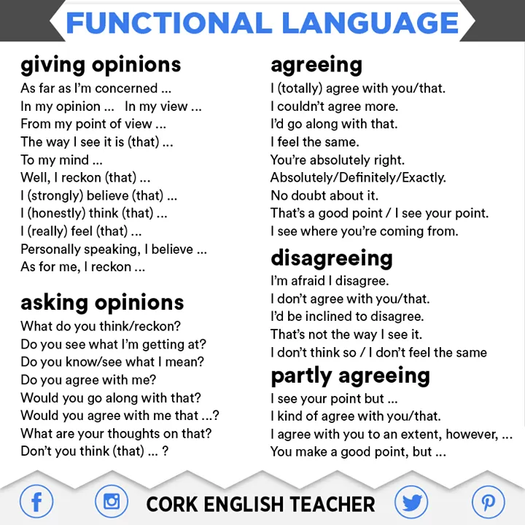
https://www.myenglishteacher.eu/blog/asking-giving-opinions-agreeing-disagreeing/

4. Grammar: Linking words
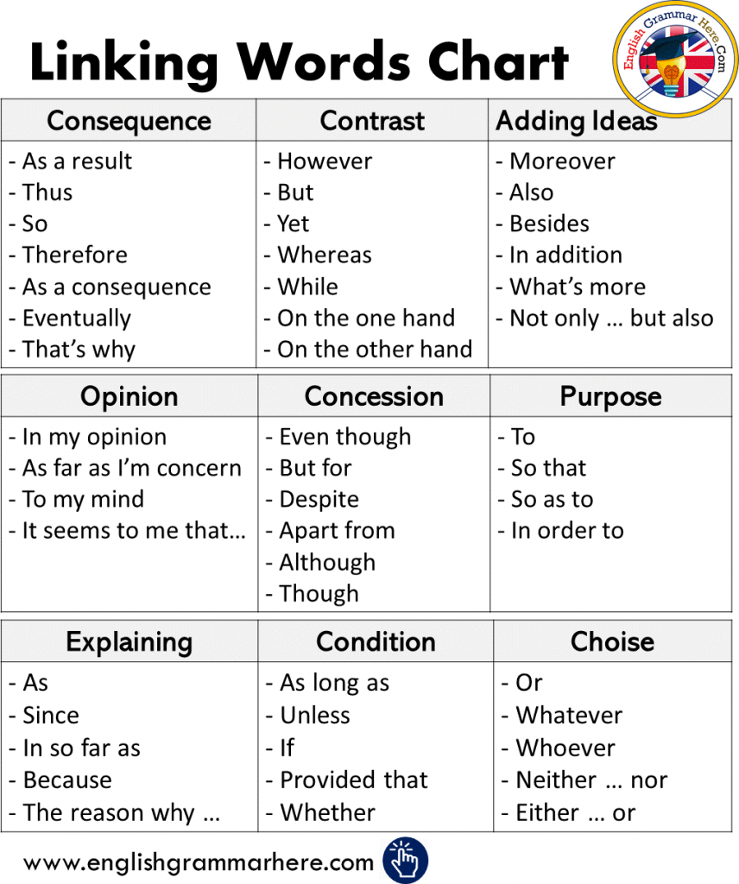
5. Dialogue in pairs. Pros x Cons
Choose one of the statements below to discuss with your partner, give your opinion, agree and disagree with him/her. Use the internet for more information to prepare the dialogue.
Excessive screen time…
Climate changes effects…
A.I. future …
Brain Rot

